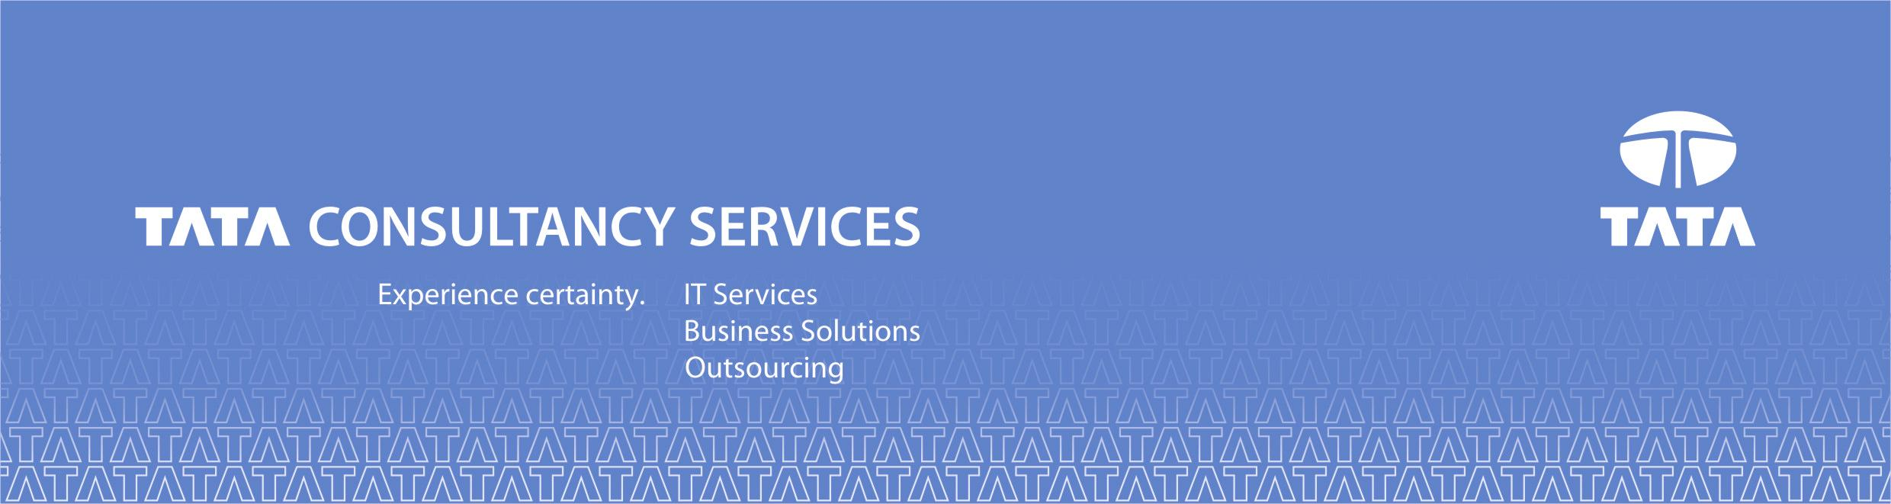

DATABASE TABLESPACE UTILIZATION – Solution Document

Version 1.1

SO_No : | DB_01
Category : | Alerts, Incidents
SO Name : | Handle Alerts related to Database Tablespace Utilization.
Summary : | Handle Alerts related to Database Tablespace Utilization.

XPERTIS – ignio CoE

Dec 2019


#16 Marg Square,
Tata Consultancy Service – ILP Center
OMR Road, Karapakkam,
Chennai - 600 097, Tamil Nadu
Ph: 6616 5111 Fax: 6616 5010

Confidentiality Statement

This is a controlled document. Unauthorized access, copying and replication are prohibited.
This document must not be copied in whole or in parts by any means, without the written authorization of the Technology Excellence Lead, TATA Consultancy Services Limited.
© TATA Consultancy Services Limited, 2019

Solution Document Release Note

This DB_01 Tablespace Utilization v1.1 document is released for use in Technology Excellence Group, Tata Consultancy Services Limited with effect from December 2019
This document is subject to document control process defined by Technology Excellence Group.
Revisions, if any, to this guide will be notified as per the communication plan.

Approved By: M Arunagirinathar
Date of Approval: 05/12/2019

SOLUTION DOCUMENT REVISION LIST

Document Name: | DB_01 Tablespace Utilization v1.1
Version No: | 1.1
Document Owner: | Abdullah Deen Mohamed

Ver. No. | Release Date | Description | Updated by | Reviewed and Approved by
V1.1 | 9/12/2019 | Solution Design Document | Abdullah Deen Mohamed | M Arunagirinathar

About the Document

Purpose

This document describes the solution design to manage incidents related to Database Tablespace Utilization.

Target Audience

The target audience for this document is IT IS ignio accounts.

CONTENT
CONTENT 6
Preface 7
INTRODUCTION 8
DEFINITIONS AND ACRONYMS 9
USE CASE REQUIREMENTS 10
1. SOLUTION OVERVIEW 11
2. SOP WORKFLOW 12
3. Test Details 13

Preface

This book provides the detailed information about to Handle Tablespace Utilization and solution with scope, pre-requisite, workflow, technology supported used etc.

Please refer to the document for the desired combination.

INTRODUCTION

This use case describes to Handle incidents related to Database Tablespace Utilization with help of ignio automation platform.

DEFINITIONS AND ACRONYMS
The definitions and acronyms that are used in the document are

Acronym | Definition / Description
DC | Domain Controller
AD | Active Directory
SO | Service Operation
SOP | Standard Operating Procedure
SAN | Storage Area Network
LAN | Local Area Network
DR | Disaster Recovery
FW | Firewall
RDP | Remote Desktop Protocol
PS | Power Shell
CREDSSP | Credential Security Support Provider protocol
OU | Organizational Unit

USE CASE REQUIREMENTS

BPPM will collect the information related to Database Tablespace utilization. Once the utilization is higher than expected, an incident is created, ignio will pull this incident and consider it for the automation process. Finally, ignio will complete the process of bringing the tablespace to be under the threshold and close the e-request. If not successful, It assigns to manual queue for resolution.

SOLUTION OVERVIEW
- Target Environment - Pre-Requisite

- OS: Linux
- Target host reachability
- Instance entry in TNS
- Oracle Listener enable
- DB environment variables set
- Database Open

- Tested Environment

- Ignio Environment
- RHEL LINUX
- Target environment Pre-requisite

- Step by Step Task

Step 1- After receiving the ticket from Remedy, Ignio creates a tickets in Ignio for same use case.
Step 2- Ignio checks whether the Tablespace is present or not in that particular DB.
Step 3- If Tablespace is present in DB, Ignio will check for its usage.
Step 4- If the Tablespace usage is more than the threshold value, it checks for the space to be added inorder to bring it under threshold.
Step 5- Then Ignio will get all the datafiles related to the Tablespace.
Step 6- Then ignio will resize the existing datafile based on its Threshold value and its File system size.
Step 7- If the Existing Datafile is already filled up, Ignio will add new datafile in the DB related filesystem based on its Threshold Value.
Step 8- Ignio will validate the tablespace usage.
Step 9- Post Completion Ignio will resolve the ticket by sending the details of the tablespace and its datafiles to the mail id.

SOP WORKFLOW

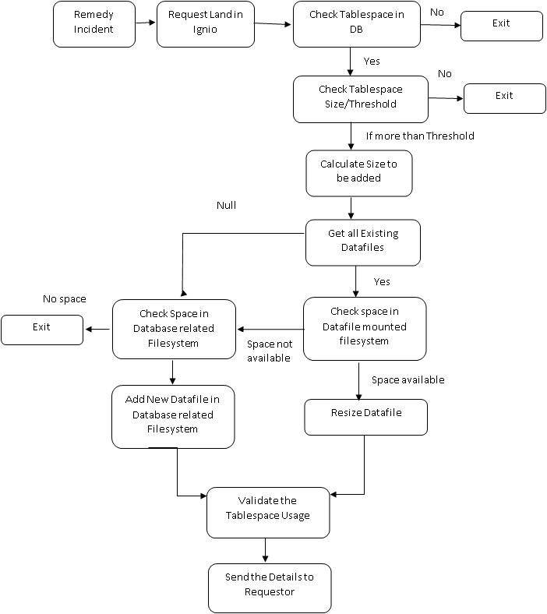

Test Details

  - Successful Ticket

